Volunteer Agreement Template

We appreciate your commitment to us and will do the best we can to make your volunteer experience with us enjoyable and rewarding. To make sure you have the best possible experience, we have created this agreement, which sets out our commitment to you and what we hope you can contribute.

Our organization is committed to:

• Giving you a great experience.
• Being responsive to your requirements.
• Providing you with a solid and well rounded introduction/orientation.
• Providing support throughout your volunteer experience.
• Explaining the standards we expect as well as encouraging and supporting you to achieve and maintain them.
• Providing a person who will be your point of contact while volunteering. This might be someone other than the volunteer manager. He or she will discuss your volunteering on a regular basis as well as your achievements and any issues that may arise.
• Doing our best to help you develop and improve your volunteering role with us.
• Being flexible in relation to your volunteering hours, recognizing your need for holiday time and other commitments.
• Honoring the time commitment you have agreed to give us and not to expect more from you unless offered and agreed.
• Providing the training required to undertake your role.
• Providing adequate training and ensure you know what to do to stay safe, in accordance with our Health and Safety Policy, Covid-19 virus, and social distancing.
• Ensuring that all volunteers are treated fairly, in accordance with our Equality and Diversity Policy.
• Trying to resolve fairly any issues or difficulties you may have while you volunteer with us before they become problems. In the event of an unresolved problem, offering an opportunity to discuss the issue in accordance with the relevant policies.
• Follow up on any feedback or questions you may have regarding your involvement as
a volunteer.

I, [Print Volunteer’s Name] Volunteer name and last name hereagree to volunteer with Guanin/SAS and am committed to the following:
• Performing my volunteering role to the best of my ability.
• Working as agreed in my volunteer role description.
• Following the organization’s policies, procedures, and restrictions.
• Familiarizing myself, and asking if I’m not certain about what to do in order to stay healthy and safe while volunteering.
• Maintaining any confidential information of the organization.
• Going to meetings and other commitments on time, as agreed, but when unable to do so, I will provide give reasonable notice so that other arrangements can be made.
• Returning any loaned equipment when ending my volunteering.

*NOTE: You must have proof that you have been completely vaccinated against the Covid-19 virus, meaning you have had both of your Moderna or Pfizer-BioNTech shots, or the one Johnson & Johnson shot, (or a brand approved in your country) and at least two weeks have passed since the last of those injections before the day of your flight to the DR on July 4. Iin other words, you must have had your final shot by June 20th.
--Also, while you are in the DR, the Dominican government requires you to wear a mask and practice social distancing of six feet.
--It’s important to know that you CANNOT USE ANY ALCOHOL OR DRUGS AT ANY TIME while you are in the DR with Guanin, regardless of your age.

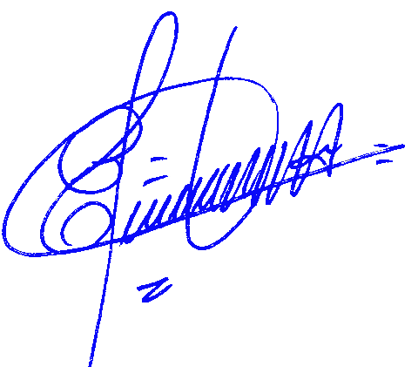
This agreement is not intended to be a legally binding contract between us and may be stopped at any time by either party.

Signed: Add your Signature here Signed:

Date: Date here please Date.: Date Here

[Volunteer Name]Your Full Name here Elias Severino Hernandez

[Volunteer Role] Add Your role here. Executive Director

